IMMC 2022 Winter—Problem D
Team Control Number: 22761451

“Efficiency is time and time is money” -- IMMC

Summary

Contents
I. Summary 1
II. Introduction 3
III. Defining the Problem 3
3.1 Question restatement 3
3.2 Assumptions 3
3.3 Variables 4
IV. Modeling Boarding and Disembarking Aircraft 5
V. Narrow Body Passenger Aircraft 5
VI. Other Passenger Aircraft 6
VII. Pandemic Situtations 6
VIII. Letter 6
IX. Strengths 6
X. Weaknesses 6
XI. Conclusion 6
XII. Appendix 6

Introduction
Efficiency, the state of working in a well-organized and competent way [3], is undoubtedly an important aspect during the boarding and disembarking of an aircraft. Due to various factors like accidents, delays, seating positions, and row numbers, the time needed in total for a plane to be completely seated would become increasingly long, which is an unwanted thing for those in a hurry. Therefore, in order to decrease and minus the possible time which can increase overall time needed, our team is to create a model which can find out the most efficient way in both boarding and disembarking a plane.

Defining the Problem

3.1 Question restatement
Our team is to complete five tasks:
- Calculate the total boarding and disembarking time and create a model which outlines the different aspects which can affect the time taken.
- Apply the model to the standard “narrow body” aircraft and, first, compare the boarding times for the boarding methods of random boarding, boarding by section, and boarding by seat. Second, we would need to analyze the how the times vary by differing numbers. Third, through the analysis and two additional boarding methods, explain the optimal boarding method and justify.
- Modify the model accordingly to the “Flying Wing” passenger aircraft and the “Two-entrance, Two-aisle” aircraft and recommend the most favorable boarding method for each kind of aircraft.
- Observe whether or not the boarding method would change if the number of passengers were limited to a specific percent.
- Write a one-page recommendation letter to an airline executive describing our results, recommendations, and rationale about passenger aircraft boarding and disembarking in a non- mathematical way.

3.2 Assumptions
In designing our model, we decided on several basic assumptions. Listed below are the assumptions and our justifications for them.
Assumption | Justification
The strength of every individual adult is the same. | We make this assumption because it is impossible to measure and predict the lifting strength of every passenger. In addition, by doing so, the function concerning the amount of time needed per passenger to stow away the luggage would be made easier due to the decrease in complexity which can make the overall process more understandable and efficient.
There are two groups of people: underaged people and the adults. They will be walking at different speeds accordingly. | It is undeniable that in real life there are people of all ages boarding planes, but even though our team’s goal is in striving for the most realistic results, the difficulty in calculating the probability of different age groups’ arrival would be simply too immense, therefore by making this assumption, our team is simplifying the problem to a reasonable amount while maintaining the two most important groups.
Children do not have any luggage | Since children have an average height of about 1.21m [1], it would be near impossible for them to lift their bags onto the overhead bins, therefore it would take up an unpredictable amount of time that is both unnecessary and unwanted in the model in case of messing up the calculation.
An infant is to be carried by an adult the entire time | FAA rules, and the airlines, do not require that infants and toddlers under the age of 2 be in a separate seat, [2], and therefore because of this, the infants do not take up one seat on the airplane, therefore they are assumed to be carried by the adult throughout the entirety of the flying session.
As long as the passenger reaches his or hers aligning row, he or she would go in without waiting people at the front to clear enough space for the person already sitting in the row to get out in. | First, it would be challenging to calculate the number of people at the back for each row in the aircraft, and second, to be realistic, it is possible to squeeze past the passenger, therefore enabling the exchange of position to get to the passengers’ seats accordingly.
The passengers are not incapacitated. | As explained above, there are two walking speeds in total, the children’s and the adults’, and since disabled people have a high probability of having a slower walking speed which varies according to the person’s age and physical condition, we will be discussing the people’s moving speed as those belonging to an unincapacitated group.
All the adult passengers have lugguage, and lift their luggage onto the overhead bins using five seconds respectively | Almost all of the adults have lugguage. As the assumption of the passengers’ strength being the same, it is safe and reasonable to make this one as well to make the calculation rid of superfluous predictions and guesses.

3.3 Variables
T_{distance} | Time needed to go a certain row
T_{luggage} | Time needed for the passenger to lift one piece of luggage onto the overhead bins
T_{delay} | Time delayed due to passenger of smaller-numbered row stowing away luggage
T(p) | Function for the total time per passenger to walk towards corresponding row, stow away luggage, and sit on the seat

Modeling Boarding and Disembarking Aircraft

Narrow Body Passenger Aircraft

  - Time Needed for each Boarding Methods
The question requires us to apply our model to the following methods:
- Random (unstructured) boarding
- Boarding by Section: Examine varying the order of aft section (rows 23-33), middle section (rows 12-22), and bow section (rows 1-11).
- Boarding by Seat: In the order of window seats (A and F), middle seats (B and E), and aisle seats (C and D).
The factors that save time can be categorized into seat shuffle and lugguage placing. In the following methods, only Boarding by Seat actually decreases some factors that affect time.
The first boarding method can be done by randomly generating the coordinates of the seat to each passenger. Running our code, rounding the numbers to a whole number, the results are the following:

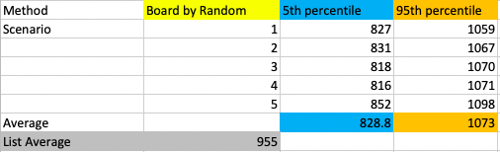

The second boarding method can be done by randomly generating the order which the passenger is going to to the given rows of the seat. By this, each of the sections have a order in which the people in row 23-33 goes the first, the people in row 12-22 goes the second, the people in row 1-11 goes the last. The results are the following:
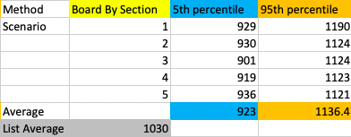

The third boarding method can be done by randomly generating the order which the passenger is going to to the given columns of the seat (ABCDEF). By this each sections have a order of first passengers on the window seats A and F, then passengers on the middle seat B and E, at last passengers on the asicle seat C and D. The results are the following:
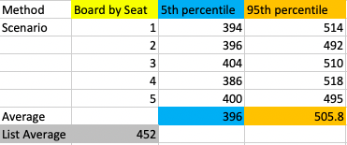

Comparing all of the data, we found out that the Boarding by Seat method is the fastest.
In all, the results are the following:

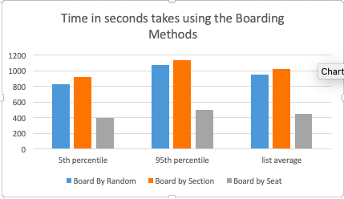

Figure 3: Bar graph comparing the time (seconds) between the methods of boarding given

  - Sensitivity Analysis
It is common for people not following directions. When boarding a plane, chaos and disorder can all happen. Using the model, we have also recorded each method’s time needed when people who don’t follow directions percentage is at 10%, 40%, and 70%. The results are the following:

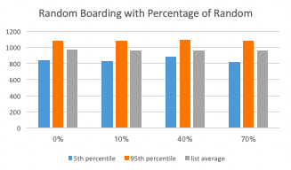
Boarding by random with the percentage of random didn’t change. It still levels at around the same place. It is easy to understand the results, as randominizing a already random sequence won’t change anything.

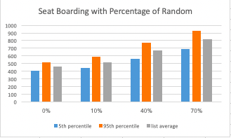
Boarding by seat have an increase of time needed, as the percentage of people who didn’t follow the rules increases. This means, that at a random rate, more seat shuffle appears.

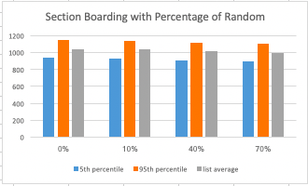

Boarding by section have a slight decrease as the percentage of people who didn’t follow the rules increases. Boarding by section is the slowest way. The slight decrease indicates that people will have a higher chance putting their lugguage simultaneously when they are in a random order than in order.

The results are amusing. An order by section is more worse than no order (random). This shows that the boarding methods must try to decrease the factors of seat shuffle and lugguage placing, rather than putting everybody in an organized order.
  - Situation of More Lugguage
Many people might bring lots of lugguage in order to save money from consignment. In this case, we have collected data at situation where two-thirds of people bring inglugguage, four-fifths of people bringing lugguage, and nine-tenths of people bringing lugguage. The results are the following:

  - Other Boarding Methods
Boarding Methods strengths and weakness can be summarized into 5 different elements:
- Lugguage Placing: When a person place their lugguage the whole line must stop.
- Seat Shuffle: When a person is blocking another person’s seat, they must come out and swap in order to let seat all the people.
- Family: Family need to be grouped together closely, so that children can be taken care.
- Groups: Numerous Groups can make the boarding very complicated.
- Rowdiness: Boarding in chaos may lower the efficiency.

- Steffen Method (which we are not using):
Met: Lugguage Placing, Seat Shuffle, Rowdiness
The fastest way of boarding the plane is presented by Jason H. Steffen, called the Steffen method [?]. This involves th line of people going into adjacent rows and putting their luggauge simultaneously. Then, another line of people come in, putting their lugguage simultaneously, etc.
This is the best way to avoid the problem of lugguage placing, and seat shuffle. In fact, it is the fastest way theoretically. However, it cannot meet the requirement of Family, Groups. This make this method not practical.
- Grouping WMA Method
Met: Groups, Rowdiness, some of Lugguage Placing, somw of Seat Shuffle
This Method involves first dividing the airplane into front and back, and then divide the sections into window, middle, asicle seats. According to the order, back W, front W, back M, front M, back A, front A, the passengers sit in.
The dividing of groups isn’t complicated and very practical. It can also, in some way,

- ______ Method
Met:

  - Optimal Disembarking Method
Not much of the disembarking method are possible. We have chosen the fastest way, as disembarking the plane needs less a “family group”.
Line by Line Method:
When the plane lands, one person sitting on the aisle seats (C or D) of each row will come out and take their luggage. The person that come out on the first row will leave first, then the other five people on the same row will leave. The second row is the same as the first, and the pattern will be the same row after row until the people from the last row depart the plane.
This method is the fastest method: it avoids the situation of getting the lugguage and seat shuffle.

Other Passenger Aircraft

Pandemic Situtations
7.1 Narrow Body Passenger Aircraft
7.2 Flying Wing Passenger Aircraft
7.3 Two Entrance, Two Aisle Passenger Aircraft

Letter

Strengths

Weaknesses

Conclusion

Appendix
[1] “Average Child Height | Onaverage.co.uk.” Onaverage.co.uk, 2019, www.onaverage.co.uk/body-averages/average-child-height.
[2] Harvey, Author Leslie. “What to Consider before Flying with a Lap Child.” Trips with Tykes, 22 May 2013, tripswithtykes.com/should-you-buy-a-seat-for-your-child-under-age-2/. Accessed 10 Mar. 2022.
[3]

